2400040454
Harsha Vardhan.
EXPERIMENT: DATA VISUALIZATION USING EXCEL
AIM: To create simple interactive excel dashboard for given data.
Outcomes: Students are able to understand visualization importance and create simple dashboard using Excel.
Apparatus/Software required: data sheet in .xls or CSV format, Excel 10, System/laptop with minimum specifications.
Procedure:
1) Check the data from sheet and clean the data whichever not essential to make dashboard.
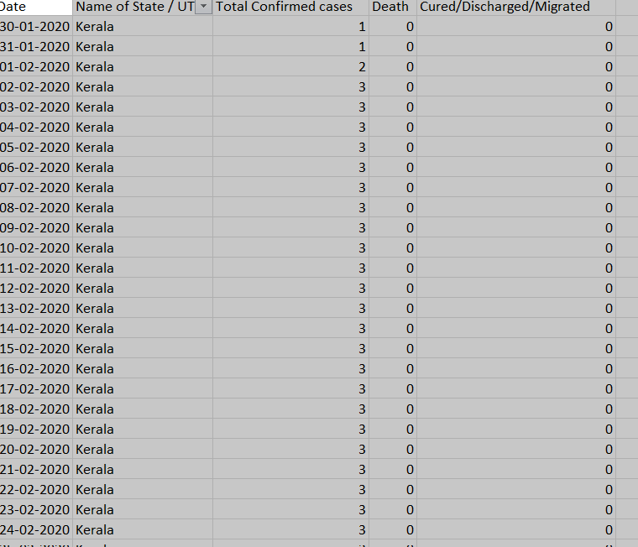
2) Create new sheet and rename it as pivot tables.
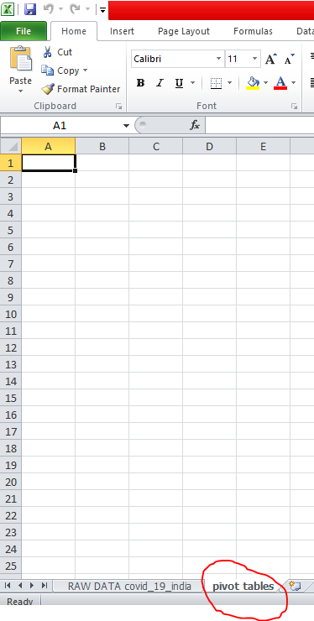
3. in pivot table sheet click on insert option and then click on pivot table.
4. Now you got pivot table asking range of the sheet or data for which table to be put. Go to raw data sheet and select the range and click ok.
5.Now the pivot table is ready with pivot table field list.
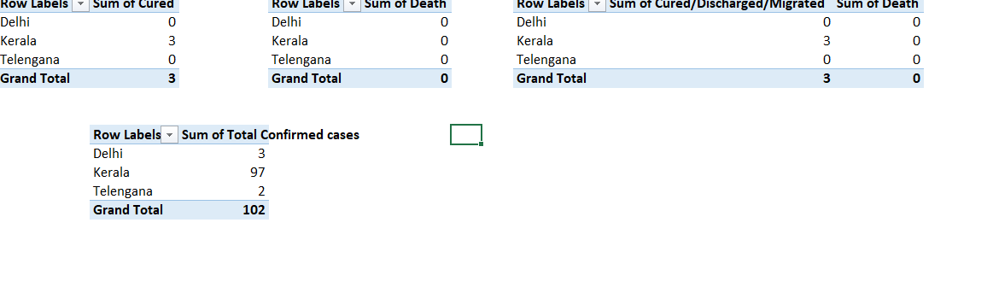7. Once you click on pivot chart it will ask you to select type of chart. As here we are having two variables to compare the data I will select column chart and click on ok.
8. Go to new sheet (click on new sheet) and rename as charts. After renaming the sheet go to view and uncheck gridlines to make sheet plain.
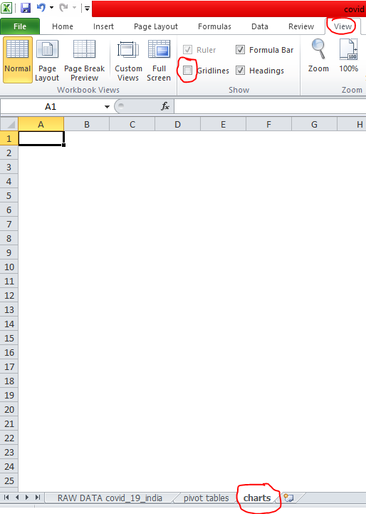
9.Repeat the procedure 9 to create required different charts, transfer all the charts drawn for pivot table using cut and paste option. Before doing it we should modify chart with effective visualization like color, axis title, chart title, data labeling etc.
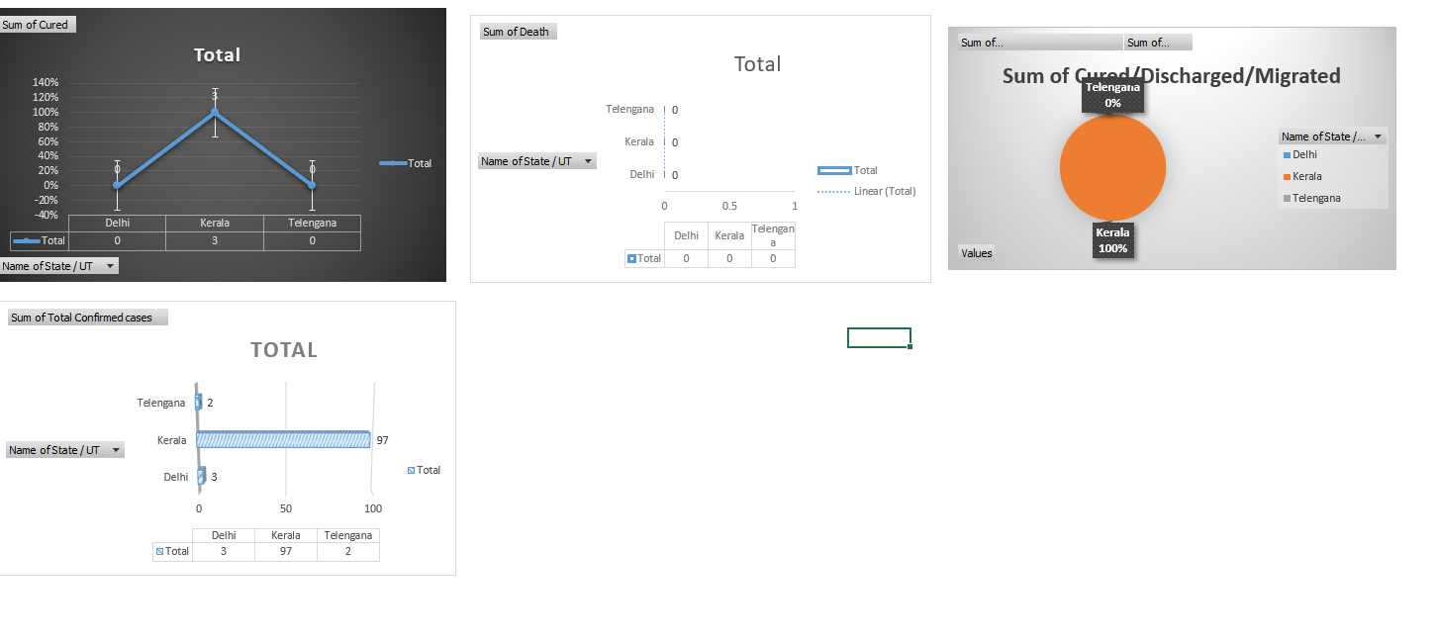
RESULT: Simple dashboard using Microsoft Excel is created.

